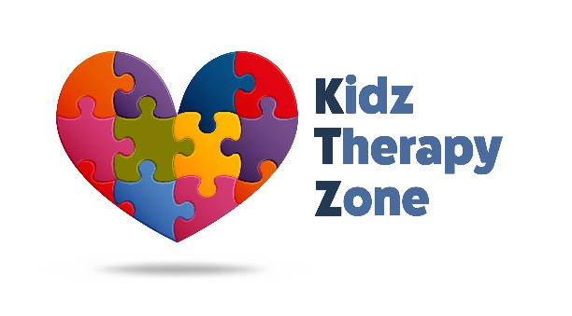
1002 S Dillard St Suite 106
Winter Garden, FL 34787
P: 407-877-0029 | F: 407-358-5207

Good evening KTZ families,
We feel it is important to stay in open communication with our Kidz Therapy Zone families concerning the COVID-19 (CoronaVirus) pandemic and its impacts. At this time, Kidz Therapy Zone remains open for therapy sessions as scheduled. It is our priority to exceed the CDC recommended sanitation and cleanliness guideline. Our therapists and other staff are working hard to ensure our facility and its equipment are safe and sanitized for continued use.
We highly encourage all families to follow the best practices listed below to help keep yourself and others healthy:
- Wash or sanitize your hands often, preferably with soap and warm water for at least 20 seconds
- Avoid touching your eyes, nose, and mouth with unwashed hands
- Stay home and cancel your appointment if you are feeling unwell, have a fever, or are experiencing shortness of breath
- Cover all coughs or sneezes with a tissue/elbow and discard of the tissue appropriately
- Feel free to bring your own disinfectant wipes with you, if you so choose. We have hand sanitizer available in the waiting room and in the therapy rooms.
KTZ is committed to continued communication with our KTZ family and hope everyone remains safe. Please note that of today (March 13th) there are no confirmed cases of COVID-19 in Orange County and we will continue to monitor the situation. In taking necessary precautions, the State of Florida has announced today that all public schools will be closed until March 30, 2020. If you would like to check alternative scheduling, please contact your designated therapist for availability.
If anything is canceled/postponed, we will notify families via email, and/or telephone. Therapy sessions will be decided upon by you and your therapist unless Kidz Therapy Zone determines that the facility itself needs to close.
Thank you for being a part of our family, and we pray for good health to everyone during this challenging time.

